F1 Driver Performance Analysis — 2025 Season
A Data-Driven Analysis of Driver Performance Beyond Championship Points
Prepared by: Surya Mani Deep
Date: September 2026
Tools: FastF1 • Python • Pandas • Power BI
1. Project Overview
Formula 1 generates extensive data throughout a season, providing valuable insights into driver performance. This project analyzes the 2025 Formula 1 season by combining race and qualifying data to evaluate drivers across multiple aspects of performance.
Rather than relying only on championship points, the analysis considers race performance, qualifying performance, consistency, and reliability. These factors are combined using a weighted scoring methodology to produce an Overall Performance Score for each driver.
The project demonstrates a complete data analysis workflow, from data collection and cleaning to analysis, scoring, and interactive visualization. Formula 1 data is collected using FastF1 and processed with Python and Pandas, while Power BI is used to present the final results.
Project Outcome
The final outcome is an interactive Power BI dashboard that enables users to explore and compare driver performance throughout the 2025 season using multiple performance metrics and the calculated Overall Performance Score.

2. Project Overview & Objectives
Project Overview
Formula 1 driver performance cannot be fully represented by championship points alone. A driver's season can be influenced by qualifying performance, race finishes, podiums, consistency, retirements, and the ability to convert qualifying positions into strong race results.
This project evaluates 2025 Formula 1 driver performance using multiple performance metrics. Race and qualifying data are analysed to provide a broader view of each driver's strengths, consistency, and reliability throughout the season.
The analysis combines these metrics into a weighted Overall Performance Score, allowing driver performance to be compared using a consistent scoring methodology. The results are presented through an interactive Power BI dashboard.

Project Objectives
The main objectives of this project are:
- Analyze Formula 1 driver performance throughout the 2025 season.
- Compare race and qualifying performance across drivers.
- Measure driver consistency and reliability.
- Analyze the difference between qualifying and race positions.
- Develop a weighted scoring system using multiple performance metrics.
- Create an interactive Power BI dashboard for exploring the results.
- Generate meaningful insights from the analyzed data.
Performance Metrics
The analysis uses eight key metrics:
- Total Points
- Win Rate
- Podium Rate
- Average Finish Position
- Finish Consistency
- DNF Rate
- Average Qualifying–Race Gap
- Average Qualifying Position
What This Report Covers
This report explains the complete workflow of the project, including data collection, data cleaning and preparation, performance metrics, scoring methodology, Power BI dashboard development, key findings, limitations, and future improvements.

3. Dataset, Tools & Data Collection
Dataset
The project uses Formula 1 session data from the 2025 season. The dataset includes information from race and qualifying sessions, with additional session data used where required for the analysis.
The collected data contains information such as:
- Driver name and abbreviation
- Team
- Grid position
- Qualifying position
- Race finishing position
- Championship points
- Podium and race results
- DNF/retirement information
- Session and race information
Data Source
The Formula 1 data was collected using the FastF1 Python library. FastF1 provides access to Formula 1 timing and session information, making it possible to retrieve structured data for different races and qualifying sessions.
The 2025 season data was collected session by session and then combined into datasets suitable for analysis.
Tools & Technologies
FastF1 — Used to retrieve Formula 1 race and qualifying session data.
Python — Used as the primary programming language for data extraction and processing.
Pandas — Used for data cleaning, transformation, aggregation, and analysis.
Power BI — Used to create the final interactive dashboard and present the analysis.
Data Collection Workflow
FastF1 → Python → Pandas → Data Cleaning → Data Analysis → CSV Files → Power BI
The collected session data was processed and organized into structured datasets before being imported into Power BI for visualization. 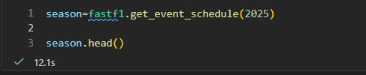
Figure 1. FastF1 data collection
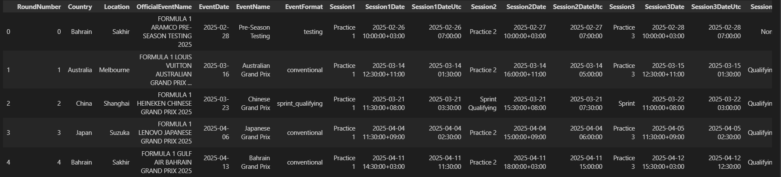
Figure 2. sample raw session data
4. Data Cleaning & Preparation
Data Cleaning
The collected data was reviewed and cleaned before calculating the performance metrics.
Key Cleaning Steps
Handling Missing Values
The datasets were checked for missing values using Pandas. Missing values were investigated to determine whether they represented genuine missing information or session-specific conditions. Where appropriate, missing records were handled without affecting valid driver results.
Standardizing Driver Information
Driver names, abbreviations, and identifiers were checked to ensure that the same driver was consistently represented across race and qualifying datasets. This was important when combining information from multiple sessions.
Handling Race Classifications
Race results can contain classifications such as:
- Finished positions
- R — Retired
- D — Disqualified
- Other non-standard classifications
These classifications were reviewed so that they did not incorrectly affect numerical calculations such as average finishing position.

Data Validation
The datasets were validated by checking:
- Number of races
- Number of qualifying sessions
- Number of drivers
- Unique driver names
- Duplicate records
- Missing values
- Column names and data types
- Race-by-race record counts
The cleaned datasets were then prepared for calculating the performance metrics.
Data Preparation
Metric | Description
Total Points | Total championship points earned during the season.
Win Rate | Percentage of races won by the driver.
Podium Rate | Percentage of races finished on the podium.
Average Finish Position | Average race finishing position.
Finish Consistency | Measures variation in finishing positions; lower variation indicates greater consistency.
DNF Rate | Percentage of races that the driver did not finish.
Average Qualifying–Race Gap | Measures the average change between qualifying position and race finishing position.
Average Qualifying Position | Average qualifying position achieved during the season.
After cleaning, the race and qualifying datasets were transformed into summary-level information for each driver. These summaries were then used to calculate the eight performance metrics and create the final scoring model.

5. Performance Metrics & Scoring Methodology
Performance Metrics
Eight metrics were selected to evaluate different aspects of driver performance.
Metric | Weight
Total Points | 25%
Win Rate | 15%
Podium Rate | 15%
DNF Rate | 15%
Average Finish Position | 10%
Average Qualifying–Race Gap | 10%
Average Qualifying Position | 5%
Finish Consistency | 5%
Total | 100%
Scoring Methodology
Because these metrics use different units and scales, their raw values cannot be directly added together. Each metric was therefore converted into a comparable score before calculating the final Overall Performance Score.
Different weights were assigned based on the role of each metric in evaluating overall driver performance.
Metric Weights
The weighted scores are combined to produce the Overall Performance Score.
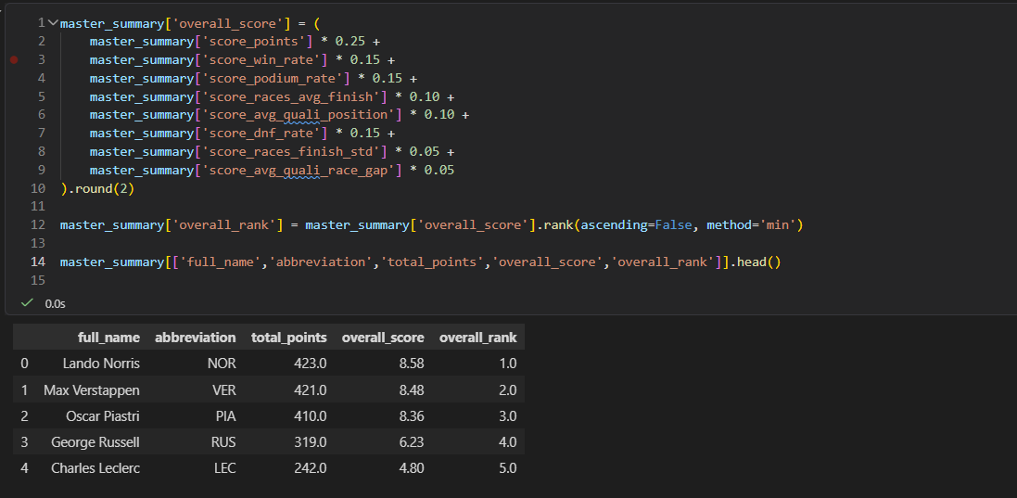
Figure 2. Weighted scoring implementation and sample output
This approach gives greater importance to championship results while still considering qualifying performance, consistency, reliability, and race execution.

6. Dashboard Walkthrough: Season Analysis
Season Rankings
The Season Rankings page gives a general summary of the 2025 season. At the top, it shows key numbers like total races, total drivers, and the championship leader, Lando Norris, with 423 points.
The main table lists all drivers, sorted by total points, showing stats such as wins, podiums, win rate, and DNF rate. On the right, a chart compares wins and podiums across the grid.
This page provides the standard championship standings, which serve as the starting point for the overall performance analysis.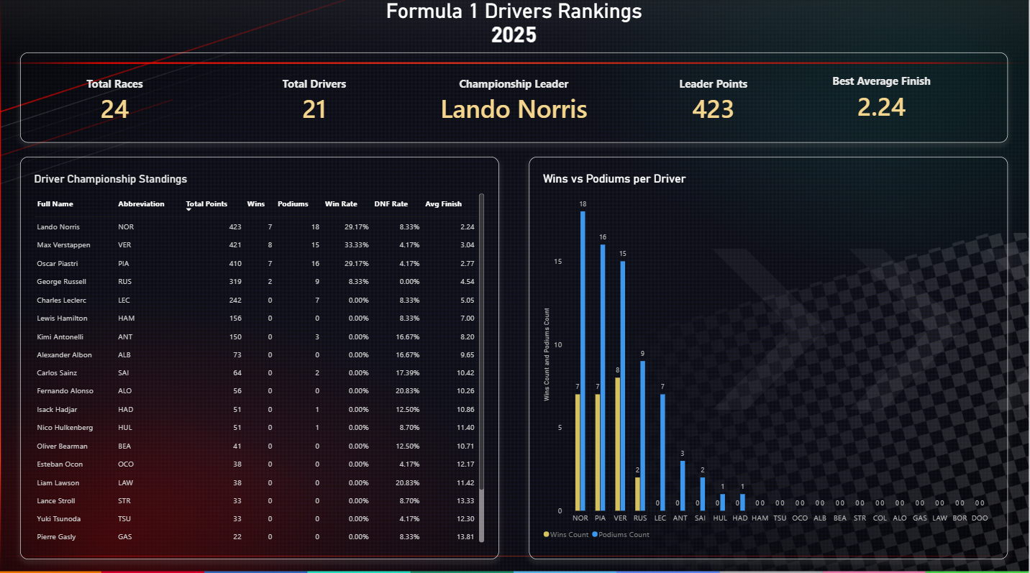

Driver Performance
The Driver Performance page provides a more detailed view of individual driver performance.
The page features two main visuals. On the left, the "Consistency vs Performance" scatter plot shows the relationship between a driver's average finish and their finish reliability.
On the right, the "Race craft - positions gained" bar chart ranks drivers by how many positions they typically gained during races, with Hulkenberg leading at +5.2.

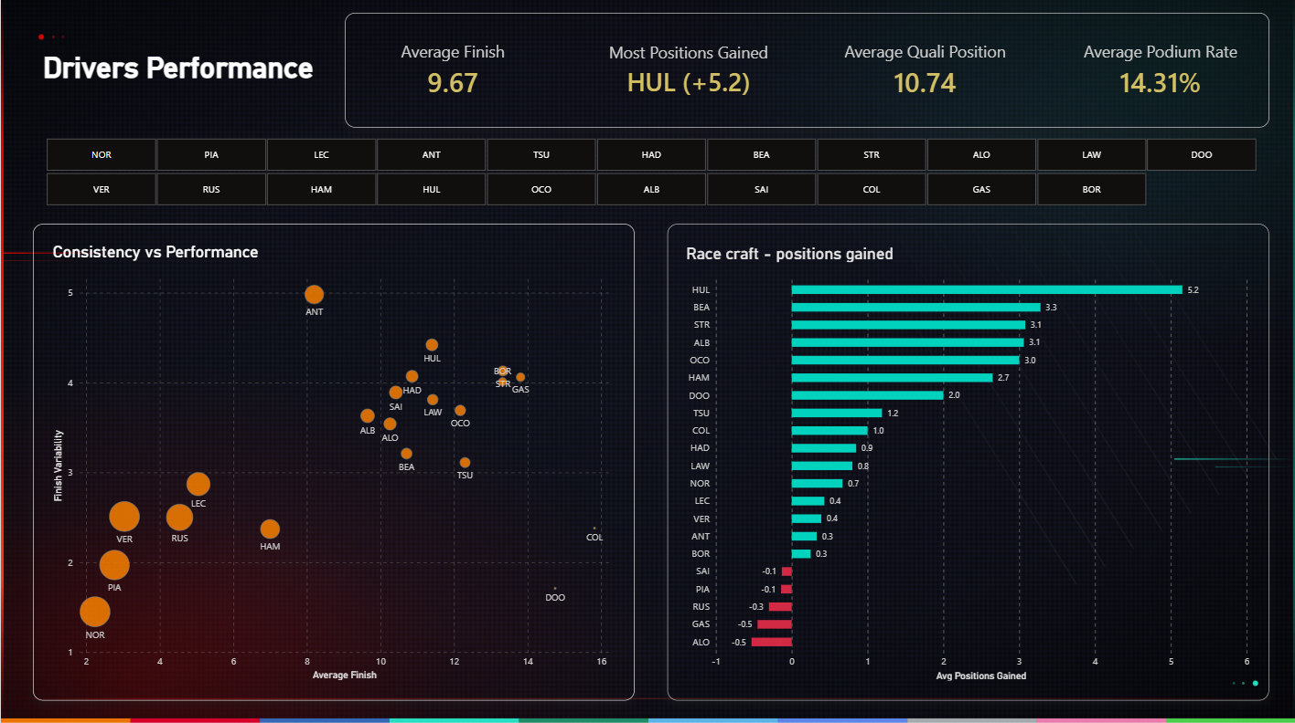
Together, these visuals help users move beyond overall standings and explore the specific factors that shaped each driver's season.
Reliability Analysis
The Reliability page focuses on how consistently drivers completed races throughout the season.
DNFs can have a significant effect on championship performance, so analysing reliability provides additional context beyond finishing positions and points.
The page allows users to compare drivers based on indicators such as DNF rate and race completion performance. 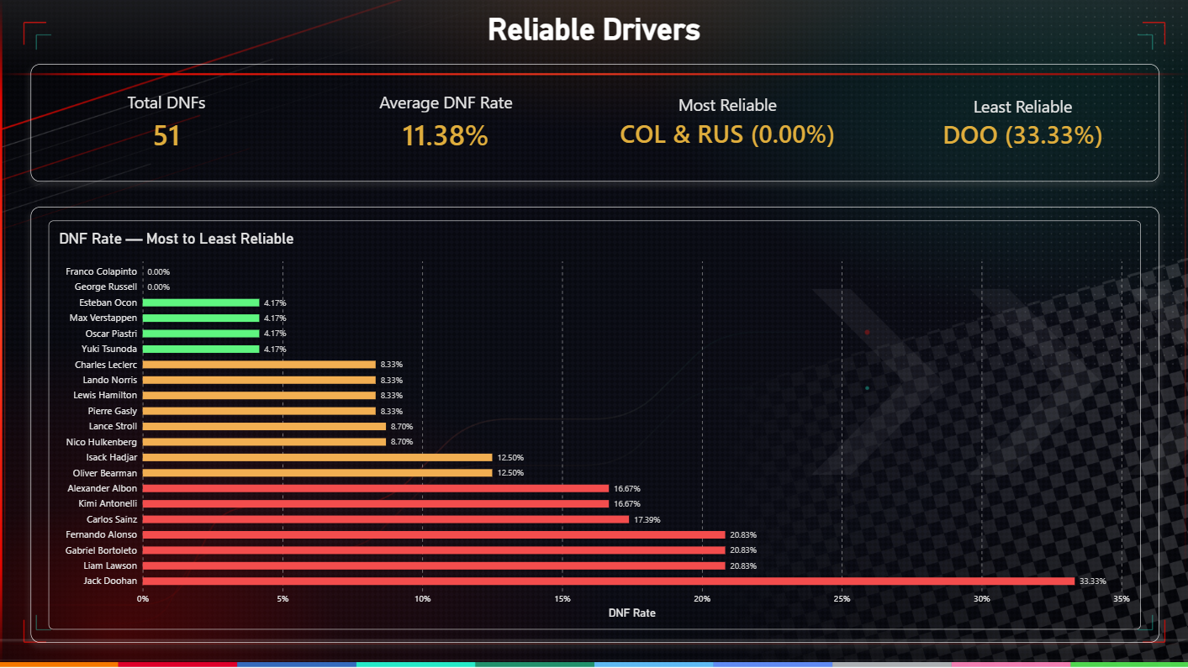

Season Trends
The Season Trends page shows how driver performance changed throughout the 2025 season.
Rather than looking only at the final season totals, this view helps identify changes in performance across different races and stages of the season.
It can be used to examine trends in points, race results, and other performance indicators over time.
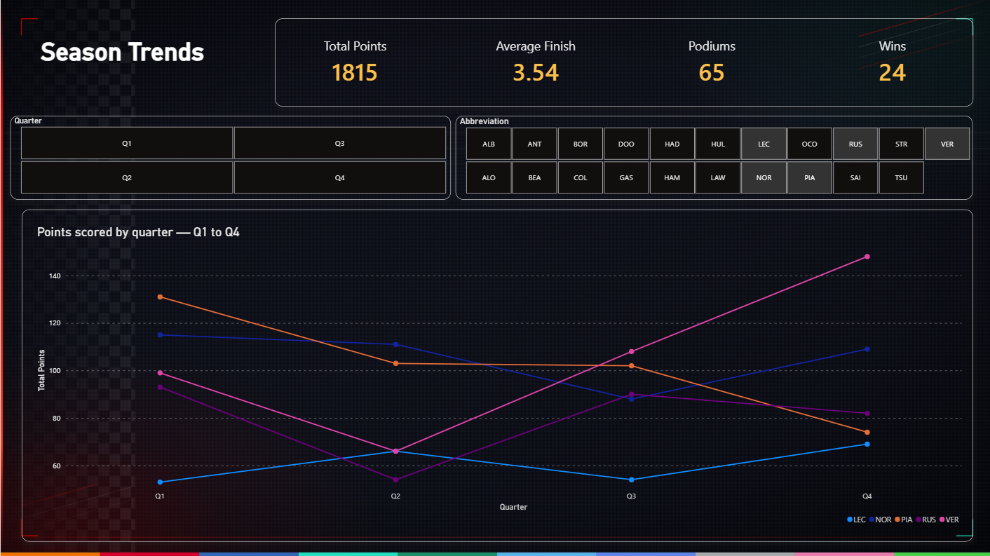 These views provide a more dynamic understanding of the season and help identify performance patterns that may not be visible from final rankings alone.

Overall Performance
The Overall Performance page brings together the major metrics and the calculated Overall Performance Score.
It provides a consolidated view of driver performance and allows users to understand how the individual metrics contribute to the final score.
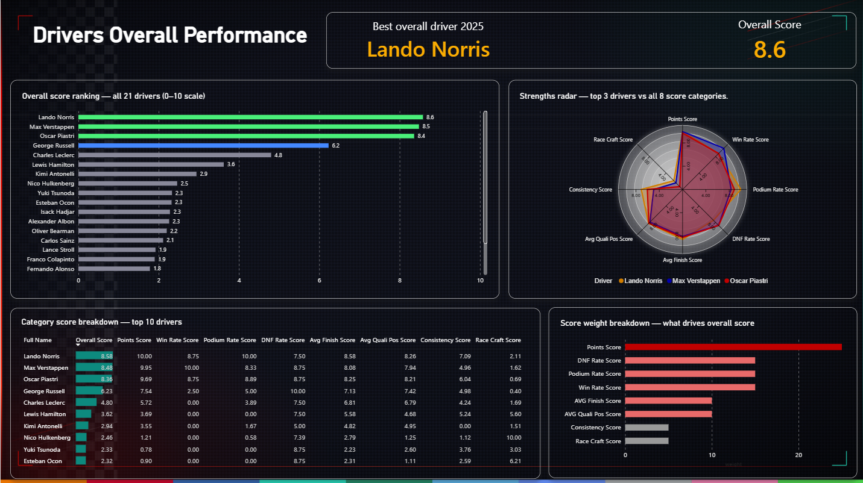 Key Findings
The analysis provides several insights into the 2025 season:
- Driver performance varies considerably when multiple metrics are considered instead of championship points alone.
- Strong championship results are reflected through metrics such as total points, wins, and podium rate.
- Qualifying performance provides additional information about a driver's speed and starting position.
- The qualifying–race gap helps identify differences between starting position and final race performance.
- Consistency and DNF rate provide additional context about a driver's season-long reliability.
- The Overall Performance Score combines these different aspects into a single comparable measure.
The dashboard allows users to explore these findings interactively and examine the individual metrics behind the overall results.

7. Limitations & Future Improvements
Limitations
Although the project provides a multi-dimensional view of driver performance, there are several limitations.
1. Driver Performance Is Affected by the Car
Formula 1 is a team sport, and driver results are strongly influenced by car performance. The scoring model evaluates driver results but does not completely separate driver performance from the competitiveness of the car.
2. Metric Selection
The Overall Performance Score is based on eight selected metrics. Other factors, such as lap pace, tyre management, pit-stop performance, overtaking, and sector performance, are not fully represented.
3. Weight Selection
The weights assigned to the metrics are based on the project's analytical approach. Different weighting choices could produce different Overall Performance Scores.
4. Data Limitations
Some Formula 1 session data may contain missing values, special classifications, or session-specific inconsistencies. These cases require careful handling during data preparation.
Future Improvements
Future versions of the project could include:
- Lap-time and pace analysis
- Tyre compound and tyre degradation analysis
- Pit-stop performance
- Overtaking and position-change analysis
- Circuit-specific driver performance
- Team-adjusted driver performance
- More advanced statistical analysis
- Automated data updates for future seasons
These additions could provide a more detailed understanding of driver and team performance.

10. Reflection & Conclusion
What I Learned
This project provided practical experience in working with a real-world dataset and developing a complete data analysis workflow.
Through the project, I gained experience in collecting Formula 1 data using FastF1, cleaning and transforming data with Python and Pandas, handling missing and inconsistent records, creating analytical metrics, and developing a weighted scoring methodology.
I also gained practical experience in Power BI, particularly in designing dashboards, creating interactive visualizations, applying filters, formatting metrics, and presenting analytical results in a clear and understandable way.
One of the main challenges was ensuring that data from different Formula 1 sessions was consistent and suitable for comparison. This required validation of driver records, missing values, race classifications, and calculated metrics before building the final dashboard.
Conclusion
The project demonstrates how Formula 1 data can be transformed into meaningful analytical insights using a combination of Python, Pandas, FastF1, and Power BI.
By combining multiple performance metrics instead of relying solely on championship points, the project provides a broader framework for analysing driver performance throughout the 2025 season.
The final Power BI dashboard brings the analysis together in an interactive format, allowing users to explore driver performance, compare key metrics, and understand the factors contributing to the Overall Performance Score.

